

**SEXTO TALLER – ALGORITMOS CON GRAFOS**

**Presentado a:**

Julio Cesar Florez Baez

**Presentado por:**

Johan Esteban Castaño Martinez - 20191020029

Jhony Alejandro Caro Umbariba - 20191020055

Samuel Andrés Romero Bueno - 20191020127

Equipo 1

Facultad de Ingeniería.

Ciencias de la Computación II.

27 de noviembre de 2022.

1. Dado el siguiente grafo:

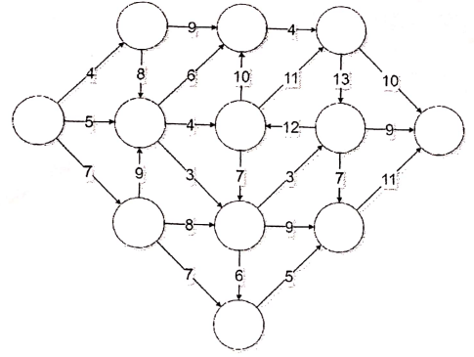

Aplicar la función ordinal, aplicar el algoritmo de Dijkstra para encontrar los caminos mínimos.

1. Dado el siguiente grafo:

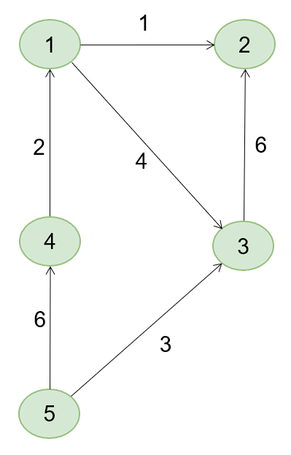

Utilizar el algoritmo de Floyd para encontrar los caminos mínimos.

**Solución:**

1. Para lograr realizar la función ordinal del grafo, tenemos que cambiar la dirección de la arista 12

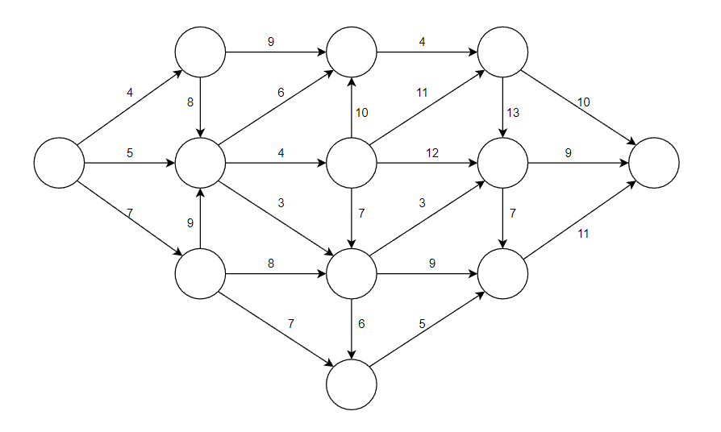

Función ordinal:

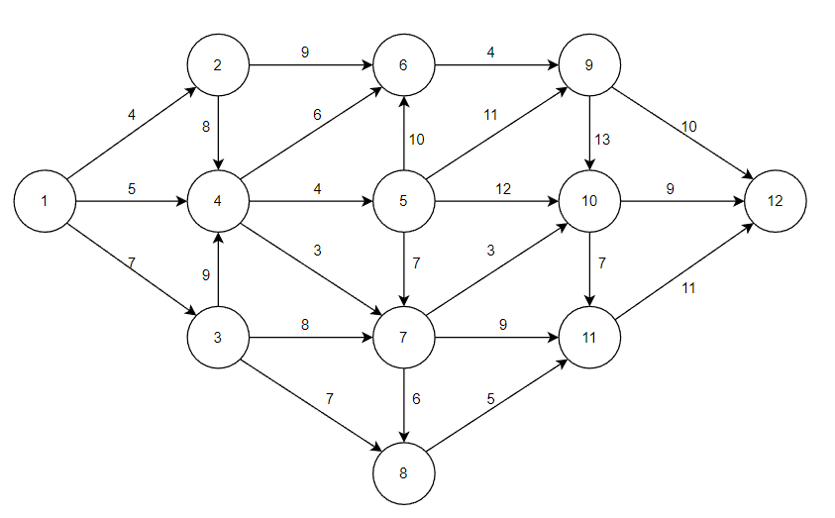

Tabla de proceso del algoritmo de Dijkstra

|  |  |  |  |
| --- | --- | --- | --- |
|  |  | Distancia más corta | Etiqueta |
| - | 1 | 0 |  |
| 1 | 2 | 4 |  |
| 1 | 3 | 5 |  |
| 1 | 4 | 7 |  |
| 2 | 6 | 13 |  |
| 2 | 4 | 12 |  |
| 4 | 5 | 9 |  |
| 4 | 6 | 11 |  |
| 4 | 7 | 8 |  |
| 3 | 4 | 16 |  |
| 3 | 7 | 15 |  |
| 3 | 8 | 14 |  |
| 7 | 8 | 14 |  |
| 7 | 10 | 11 |  |
| 7 | 11 | 16 |  |
| 5 | 6 | 19 |  |
| 5 | 7 | 16 |  |
| 5 | 9 | 20 |  |
| 5 | 10 | 21 |  |
| 10 | 12 | 20 |  |
| 10 | 11 | 18 |  |
| 8 | 11 | 19 |  |
| 11 | 12 | 27 |  |
| 9 | 10 | 33 |  |
| 9 | 12 | 30 |  |

Grafo final después de aplicar el algoritmo de Dijkstra

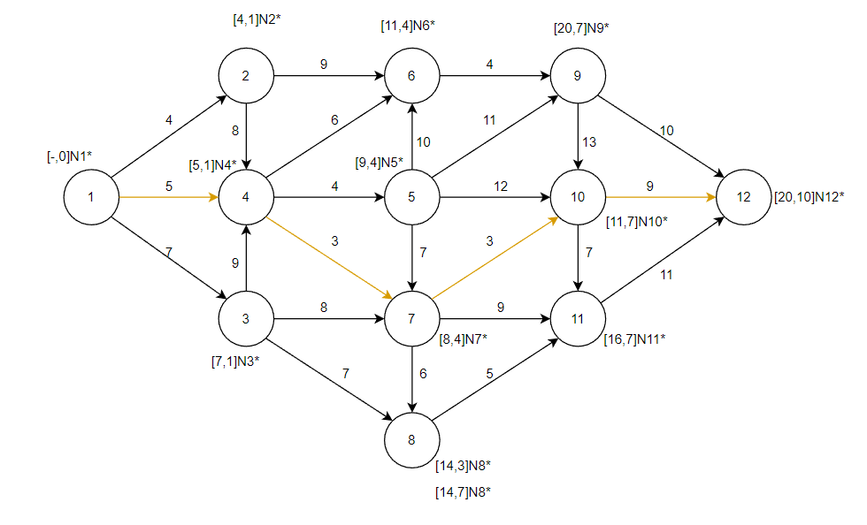

1. Algoritmo de Floyd para encontrar los caminos mínimos en el siguiente grafo:



|  |  |  |  |  |  |  |  |  |  |  |  |  |  |  |  |  |  |  |  |  |  |  |  |
| --- | --- | --- | --- | --- | --- | --- | --- | --- | --- | --- | --- | --- | --- | --- | --- | --- | --- | --- | --- | --- | --- | --- | --- |
|  |  |  |  |  |  |  | Condición | | | | | | | | | | |  |  |  |  |  |  |
| Matriz de distancias | | | | | |  | J | I | K | Di | j | + | Dj | k | < | Di | k |  |  |  |  |  |  |
|  | 1 | 2 | 3 | 4 | 5 |  | 1 | 1 | 1 | 1 | 1 |  | 1 | 1 |  | 1 | 1 | 0 | + | 0 | < | 0 |  |
| 1 | 0 | 1 | 4 | ∞ | ∞ |  | 1 | 1 | 2 | 1 | 1 |  | 1 | 2 |  | 1 | 2 | 0 | + | 1 | < | 1 |  |
| 2 | ∞ | 0 | ∞ | ∞ | ∞ |  | 1 | 1 | 3 | 1 | 1 |  | 1 | 3 |  | 1 | 3 | 0 | + | 4 | < | 4 |  |
| 3 | ∞ | 6 | 0 | ∞ | ∞ |  | 1 | 1 | 4 | 1 | 1 |  | 1 | 4 |  | 1 | 4 | 0 | + | ∞ | < | ∞ |  |
| 4 | 2 | ∞ | ∞ | 0 | ∞ |  | 1 | 1 | 5 | 1 | 1 |  | 1 | 5 |  | 1 | 5 | 0 | + | ∞ | < | ∞ |  |
| 5 | ∞ | ∞ | 3 | 6 | 0 |  |  |  |  |  |  |  |  |  |  |  |  |  |  |  |  |  |  |
|  |  |  |  |  |  |  | Condición | | | | | | | | | | |  |  |  |  |  |  |
| Matriz de Recorridos 1 | | | | | |  | J | I | K | Di | j | + | Dj | k | < | Di | k |  |  |  |  |  |  |
|  | 1 | 2 | 3 | 4 | 5 |  | 1 | 2 | 1 | 2 | 1 |  | 1 | 1 |  | 2 | 1 | ∞ | + | 0 | < | ∞ |  |
| 1 | 0 | 1 | 4 | ∞ | ∞ |  | 1 | 2 | 2 | 2 | 1 |  | 1 | 2 |  | 2 | 2 | ∞ | + | 1 | < | 0 |  |
| 2 | ∞ | 0 | ∞ | ∞ | ∞ |  | 1 | 2 | 3 | 2 | 1 |  | 1 | 3 |  | 2 | 3 | ∞ | + | 4 | < | ∞ |  |
| 3 | ∞ | 6 | 0 | ∞ | ∞ |  | 1 | 2 | 4 | 2 | 1 |  | 1 | 4 |  | 2 | 4 | ∞ | + | ∞ | < | ∞ |  |
| 4 | 2 | 3 | 6 | 0 | ∞ |  | 1 | 2 | 5 | 2 | 1 |  | 1 | 5 |  | 2 | 5 | ∞ | + | ∞ | < | ∞ |  |
| 5 | ∞ | ∞ | 3 | 6 | 0 |  |  |  |  |  |  |  |  |  |  |  |  |  |  |  |  |  |  |
|  |  |  |  |  |  |  | Condición | | | | | | | | | | |  |  |  |  |  |  |
|  |  |  |  |  |  |  | J | I | K | Di | j | + | Dj | k | < | Di | k |  |  |  |  |  |  |
|  |  |  |  |  |  |  | 1 | 3 | 1 | 3 | 1 |  | 1 | 1 |  | 3 | 1 | ∞ | + | 0 | < | ∞ |  |
|  |  |  |  |  |  |  | 1 | 3 | 2 | 3 | 1 |  | 1 | 2 |  | 3 | 2 | ∞ | + | 1 | < | 6 |  |
|  |  |  |  |  |  |  | 1 | 3 | 3 | 3 | 1 |  | 1 | 3 |  | 3 | 3 | ∞ | + | 4 | < | 0 |  |
|  |  |  |  |  |  |  | 1 | 3 | 4 | 3 | 1 |  | 1 | 4 |  | 3 | 4 | ∞ | + | ∞ | < | ∞ |  |
|  |  |  |  |  |  |  | 1 | 3 | 5 | 3 | 1 |  | 1 | 5 |  | 3 | 5 | ∞ | + | ∞ | < | ∞ |  |
|  |  |  |  |  |  |  |  |  |  |  |  |  |  |  |  |  |  |  |  |  |  |  |  |
|  |  |  |  |  |  |  | Condición | | | | | | | | | | |  |  |  |  |  |  |
|  |  |  |  |  |  |  | J | I | K | Di | j | + | Dj | k | < | Di | k |  |  |  |  |  |  |
|  |  |  |  |  |  |  | 1 | 4 | 1 | 4 | 1 |  | 1 | 1 |  | 4 | 1 | 2 | + | 0 | < | 2 |  |
|  |  |  |  |  |  |  | 1 | 4 | 2 | 4 | 1 |  | 1 | 2 |  | 4 | 2 | 2 | + | 1 | < | ∞ |  |
|  |  |  |  |  |  |  | 1 | 4 | 3 | 4 | 1 |  | 1 | 3 |  | 4 | 3 | 2 | + | 4 | < | ∞ |  |
|  |  |  |  |  |  |  | 1 | 4 | 4 | 4 | 1 |  | 1 | 4 |  | 4 | 4 | 2 | + | ∞ | < | 0 |  |
|  |  |  |  |  |  |  | 1 | 4 | 5 | 4 | 1 |  | 1 | 5 |  | 4 | 5 | 2 | + | ∞ | < | ∞ |  |
|  |  |  |  |  |  |  |  |  |  |  |  |  |  |  |  |  |  |  |  |  |  |  |  |
|  |  |  |  |  |  |  | Condición | | | | | | | | | | |  |  |  |  |  |  |
|  |  |  |  |  |  |  | J | I | K | Di | j | + | Dj | k | < | Di | k |  |  |  |  |  |  |
|  |  |  |  |  |  |  | 1 | 5 | 1 | 5 | 1 |  | 1 | 1 |  | 5 | 1 | ∞ | + | 0 | < | ∞ |  |
|  |  |  |  |  |  |  | 1 | 5 | 2 | 5 | 1 |  | 1 | 2 |  | 5 | 2 | ∞ | + | 1 | < | ∞ |  |
|  |  |  |  |  |  |  | 1 | 5 | 3 | 5 | 1 |  | 1 | 3 |  | 5 | 3 | ∞ | + | 4 | < | 3 |  |
|  |  |  |  |  |  |  | 1 | 5 | 4 | 5 | 1 |  | 1 | 4 |  | 5 | 4 | ∞ | + | ∞ | < | 6 |  |
|  |  |  |  |  |  |  | 1 | 5 | 5 | 5 | 1 |  | 1 | 5 |  | 5 | 5 | ∞ | + | ∞ | < | 0 |  |

|  |  |  |  |  |  |  |  |  |  |  |  |  |  |  |  |  |  |  |  |  |  |  |  |
| --- | --- | --- | --- | --- | --- | --- | --- | --- | --- | --- | --- | --- | --- | --- | --- | --- | --- | --- | --- | --- | --- | --- | --- |
|  |  |  |  |  |  |  | Condición | | | | | | | | | | |  |  |  |  |  |  |
| Matriz de Recorridos 1 | | | | | |  | J | I | K | Di | j | + | Dj | k | < | Di | k |  |  |  |  |  |  |
|  | 1 | 2 | 3 | 4 | 5 |  | 2 | 1 | 1 | 1 | 2 |  | 2 | 1 |  | 1 | 1 | 1 | + | ∞ | < | 0 |  |
| 1 | 0 | 1 | 4 | ∞ | ∞ |  | 2 | 1 | 2 | 1 | 2 |  | 2 | 2 |  | 1 | 2 | 1 | + | 0 | < | 1 |  |
| 2 | ∞ | 0 | ∞ | ∞ | ∞ |  | 2 | 1 | 3 | 1 | 2 |  | 2 | 3 |  | 1 | 3 | 1 | + | ∞ | < | 4 |  |
| 3 | ∞ | 6 | 0 | ∞ | ∞ |  | 2 | 1 | 4 | 1 | 2 |  | 2 | 4 |  | 1 | 4 | 1 | + | ∞ | < | ∞ |  |
| 4 | 2 | 3 | 6 | 0 | ∞ |  | 2 | 1 | 5 | 1 | 2 |  | 2 | 5 |  | 1 | 5 | 1 | + | ∞ | < | ∞ |  |
| 5 | ∞ | ∞ | 3 | 6 | 0 |  |  |  |  |  |  |  |  |  |  |  |  |  |  |  |  |  |  |
|  |  |  |  |  |  |  | Condición | | | | | | | | | | |  |  |  |  |  |  |
|  | Matriz de Recorridos 2 | | | |  |  | J | I | K | Di | j | + | Dj | k | < | Di | k |  |  |  |  |  |  |
|  | 1 | 2 | 3 | 4 | 5 |  | 2 | 2 | 1 | 2 | 2 |  | 2 | 1 |  | 2 | 1 | 0 | + | ∞ | < | ∞ |  |
| 1 | 0 | 1 | 4 | ∞ | ∞ |  | 2 | 2 | 2 | 2 | 2 |  | 2 | 2 |  | 2 | 2 | 0 | + | 0 | < | 0 |  |
| 2 | ∞ | 0 | ∞ | ∞ | ∞ |  | 2 | 2 | 3 | 2 | 2 |  | 2 | 3 |  | 2 | 3 | 0 | + | ∞ | < | ∞ |  |
| 3 | ∞ | 6 | 0 | ∞ | ∞ |  | 2 | 2 | 4 | 2 | 2 |  | 2 | 4 |  | 2 | 4 | 0 | + | ∞ | < | ∞ |  |
| 4 | 2 | 3 | 6 | 0 | ∞ |  | 2 | 2 | 5 | 2 | 2 |  | 2 | 5 |  | 2 | 5 | 0 | + | ∞ | < | ∞ |  |
| 5 | ∞ | ∞ | 3 | 6 | 0 |  |  |  |  |  |  |  |  |  |  |  |  |  |  |  |  |  |  |
|  |  |  |  |  |  |  | Condición | | | | | | | | | | |  |  |  |  |  |  |
|  |  |  |  |  |  |  | J | I | K | Di | j | + | Dj | k | < | Di | k |  |  |  |  |  |  |
|  |  |  |  |  |  |  | 2 | 3 | 1 | 3 | 2 |  | 2 | 1 |  | 3 | 1 | 6 | + | ∞ | < | ∞ |  |
|  |  |  |  |  |  |  | 2 | 3 | 2 | 3 | 2 |  | 2 | 2 |  | 3 | 2 | 6 | + | 0 | < | 6 |  |
|  |  |  |  |  |  |  | 2 | 3 | 3 | 3 | 2 |  | 2 | 3 |  | 3 | 3 | 6 | + | ∞ | < | 0 |  |
|  |  |  |  |  |  |  | 2 | 3 | 4 | 3 | 2 |  | 2 | 4 |  | 3 | 4 | 6 | + | ∞ | < | ∞ |  |
|  |  |  |  |  |  |  | 2 | 3 | 5 | 3 | 2 |  | 2 | 5 |  | 3 | 5 | 6 | + | ∞ | < | ∞ |  |
|  |  |  |  |  |  |  |  |  |  |  |  |  |  |  |  |  |  |  |  |  |  |  |  |
|  |  |  |  |  |  |  | Condición | | | | | | | | | | |  |  |  |  |  |  |
|  |  |  |  |  |  |  | J | I | K | Di | j | + | Dj | k | < | Di | k |  |  |  |  |  |  |
|  |  |  |  |  |  |  | 2 | 4 | 1 | 4 | 2 |  | 2 | 1 |  | 4 | 1 | 3 | + | ∞ | < | 2 |  |
|  |  |  |  |  |  |  | 2 | 4 | 2 | 4 | 2 |  | 2 | 2 |  | 4 | 2 | 3 | + | 0 | < | 3 |  |
|  |  |  |  |  |  |  | 2 | 4 | 3 | 4 | 2 |  | 2 | 3 |  | 4 | 3 | 3 | + | ∞ | < | 6 |  |
|  |  |  |  |  |  |  | 2 | 4 | 4 | 4 | 2 |  | 2 | 4 |  | 4 | 4 | 3 | + | ∞ | < | 0 |  |
|  |  |  |  |  |  |  | 2 | 4 | 5 | 4 | 2 |  | 2 | 5 |  | 4 | 5 | 3 | + | ∞ | < | ∞ |  |
|  |  |  |  |  |  |  |  |  |  |  |  |  |  |  |  |  |  |  |  |  |  |  |  |
|  |  |  |  |  |  |  | Condición | | | | | | | | | | |  |  |  |  |  |  |
|  |  |  |  |  |  |  | J | I | K | Di | j | + | Dj | k | < | Di | k |  |  |  |  |  |  |
|  |  |  |  |  |  |  | 2 | 5 | 1 | 5 | 2 |  | 2 | 1 |  | 5 | 1 | ∞ | + | ∞ | < | ∞ |  |
|  |  |  |  |  |  |  | 2 | 5 | 2 | 5 | 2 |  | 2 | 2 |  | 5 | 2 | ∞ | + | 0 | < | ∞ |  |
|  |  |  |  |  |  |  | 2 | 5 | 3 | 5 | 2 |  | 2 | 3 |  | 5 | 3 | ∞ | + | ∞ | < | 3 |  |
|  |  |  |  |  |  |  | 2 | 5 | 4 | 5 | 2 |  | 2 | 4 |  | 5 | 4 | ∞ | + | ∞ | < | 6 |  |
|  |  |  |  |  |  |  | 2 | 5 | 5 | 5 | 2 |  | 2 | 5 |  | 5 | 5 | ∞ | + | ∞ | < | 0 |  |

|  |  |  |  |  |  |  |  |  |  |  |  |  |  |  |  |  |  |  |  |  |  |  |  |
| --- | --- | --- | --- | --- | --- | --- | --- | --- | --- | --- | --- | --- | --- | --- | --- | --- | --- | --- | --- | --- | --- | --- | --- |
|  |  |  |  |  |  |  | Condición | | | | | | | | | | |  |  |  |  |  |  |
|  | Matriz de Recorridos 2 | | | |  |  | J | I | K | Di | j | + | Dj | k | < | Di | k |  |  |  |  |  |  |
|  | 1 | 2 | 3 | 4 | 5 |  | 3 | 1 | 1 | 1 | 3 |  | 3 | 1 |  | 1 | 1 | 4 | + | ∞ | < | 0 |  |
| 1 | 0 | 1 | 4 | ∞ | ∞ |  | 3 | 1 | 2 | 1 | 3 |  | 3 | 2 |  | 1 | 2 | 4 | + | 6 | < | 1 |  |
| 2 | ∞ | 0 | ∞ | ∞ | ∞ |  | 3 | 1 | 3 | 1 | 3 |  | 3 | 3 |  | 1 | 3 | 4 | + | 0 | < | 4 |  |
| 3 | ∞ | 6 | 0 | ∞ | ∞ |  | 3 | 1 | 4 | 1 | 3 |  | 3 | 4 |  | 1 | 4 | 4 | + | ∞ | < | ∞ |  |
| 4 | 2 | 3 | 6 | 0 | ∞ |  | 3 | 1 | 5 | 1 | 3 |  | 3 | 5 |  | 1 | 5 | 4 | + | ∞ | < | ∞ |  |
| 5 | ∞ | ∞ | 3 | 6 | 0 |  |  |  |  |  |  |  |  |  |  |  |  |  |  |  |  |  |  |
|  |  |  |  |  |  |  | Condición | | | | | | | | | | |  |  |  |  |  |  |
| Matriz de Recorridos 3 | | | | | |  | J | I | K | Di | j | + | Dj | k | < | Di | k |  |  |  |  |  |  |
|  | 1 | 2 | 3 | 4 | 5 |  | 3 | 2 | 1 | 2 | 3 |  | 3 | 1 |  | 2 | 1 | ∞ | + | ∞ | < | ∞ |  |
| 1 | 0 | 1 | 4 | ∞ | ∞ |  | 3 | 2 | 2 | 2 | 3 |  | 3 | 2 |  | 2 | 2 | ∞ | + | 6 | < | 0 |  |
| 2 | ∞ | 0 | ∞ | ∞ | ∞ |  | 3 | 2 | 3 | 2 | 3 |  | 3 | 3 |  | 2 | 3 | ∞ | + | 0 | < | ∞ |  |
| 3 | ∞ | 6 | 0 | ∞ | ∞ |  | 3 | 2 | 4 | 2 | 3 |  | 3 | 4 |  | 2 | 4 | ∞ | + | ∞ | < | ∞ |  |
| 4 | 2 | 3 | 6 | 0 | ∞ |  | 3 | 2 | 5 | 2 | 3 |  | 3 | 5 |  | 2 | 5 | ∞ | + | ∞ | < | ∞ |  |
| 5 | ∞ | 9 | 3 | 6 | 0 |  |  |  |  |  |  |  |  |  |  |  |  |  |  |  |  |  |  |
|  |  |  |  |  |  |  | Condición | | | | | | | | | | |  |  |  |  |  |  |
|  |  |  |  |  |  |  | J | I | K | Di | j | + | Dj | k | < | Di | k |  |  |  |  |  |  |
|  |  |  |  |  |  |  | 3 | 3 | 1 | 3 | 3 |  | 3 | 1 |  | 3 | 1 | 0 | + | ∞ | < | ∞ |  |
|  |  |  |  |  |  |  | 3 | 3 | 2 | 3 | 3 |  | 3 | 2 |  | 3 | 2 | 0 | + | 6 | < | 6 |  |
|  |  |  |  |  |  |  | 3 | 3 | 3 | 3 | 3 |  | 3 | 3 |  | 3 | 3 | 0 | + | 0 | < | 0 |  |
|  |  |  |  |  |  |  | 3 | 3 | 4 | 3 | 3 |  | 3 | 4 |  | 3 | 4 | 0 | + | ∞ | < | ∞ |  |
|  |  |  |  |  |  |  | 3 | 3 | 5 | 3 | 3 |  | 3 | 5 |  | 3 | 5 | 0 | + | ∞ | < | ∞ |  |
|  |  |  |  |  |  |  |  |  |  |  |  |  |  |  |  |  |  |  |  |  |  |  |  |
|  |  |  |  |  |  |  | Condición | | | | | | | | | | |  |  |  |  |  |  |
|  |  |  |  |  |  |  | J | I | K | Di | j | + | Dj | k | < | Di | k |  |  |  |  |  |  |
|  |  |  |  |  |  |  | 3 | 4 | 1 | 4 | 3 |  | 3 | 1 |  | 4 | 1 | 6 | + | ∞ | < | 2 |  |
|  |  |  |  |  |  |  | 3 | 4 | 2 | 4 | 3 |  | 3 | 2 |  | 4 | 2 | 6 | + | 6 | < | 3 |  |
|  |  |  |  |  |  |  | 3 | 4 | 3 | 4 | 3 |  | 3 | 3 |  | 4 | 3 | 6 | + | 0 | < | 6 |  |
|  |  |  |  |  |  |  | 3 | 4 | 4 | 4 | 3 |  | 3 | 4 |  | 4 | 4 | 6 | + | ∞ | < | 0 |  |
|  |  |  |  |  |  |  | 3 | 4 | 5 | 4 | 3 |  | 3 | 5 |  | 4 | 5 | 6 | + | ∞ | < | ∞ |  |
|  |  |  |  |  |  |  |  |  |  |  |  |  |  |  |  |  |  |  |  |  |  |  |  |
|  |  |  |  |  |  |  | Condición | | | | | | | | | | |  |  |  |  |  |  |
|  |  |  |  |  |  |  | J | I | K | Di | j | + | Dj | k | < | Di | k |  |  |  |  |  |  |
|  |  |  |  |  |  |  | 3 | 5 | 1 | 5 | 3 |  | 3 | 1 |  | 5 | 1 | 3 | + | ∞ | < | ∞ |  |
|  |  |  |  |  |  |  | 3 | 5 | 2 | 5 | 3 |  | 3 | 2 |  | 5 | 2 | 3 | + | 6 | < | ∞ |  |
|  |  |  |  |  |  |  | 3 | 5 | 3 | 5 | 3 |  | 3 | 3 |  | 5 | 3 | 3 | + | 0 | < | 3 |  |
|  |  |  |  |  |  |  | 3 | 5 | 4 | 5 | 3 |  | 3 | 4 |  | 5 | 4 | 3 | + | ∞ | < | 6 |  |
|  |  |  |  |  |  |  | 3 | 5 | 5 | 5 | 3 |  | 3 | 5 |  | 5 | 5 | 3 | + | ∞ | < | 0 |  |

|  |  |  |  |  |  |  |  |  |  |  |  |  |  |  |  |  |  |  |  |  |  |  |  |
| --- | --- | --- | --- | --- | --- | --- | --- | --- | --- | --- | --- | --- | --- | --- | --- | --- | --- | --- | --- | --- | --- | --- | --- |
|  |  |  |  |  |  |  | Condición | | | | | | | | | | |  |  |  |  |  |  |
| Matriz de Recorridos 3 | | | | | |  | J | I | K | Di | j | + | Dj | k | < | Di | k |  |  |  |  |  |  |
|  | 1 | 2 | 3 | 4 | 5 |  | 4 | 1 | 1 | 1 | 4 |  | 4 | 1 |  | 1 | 1 | ∞ | + | 2 | < | 0 |  |
| 1 | 0 | 1 | 4 | ∞ | ∞ |  | 4 | 1 | 2 | 1 | 4 |  | 4 | 2 |  | 1 | 2 | ∞ | + | 3 | < | 1 |  |
| 2 | ∞ | 0 | ∞ | ∞ | ∞ |  | 4 | 1 | 3 | 1 | 4 |  | 4 | 3 |  | 1 | 3 | ∞ | + | 6 | < | 4 |  |
| 3 | ∞ | 6 | 0 | ∞ | ∞ |  | 4 | 1 | 4 | 1 | 4 |  | 4 | 4 |  | 1 | 4 | ∞ | + | 0 | < | ∞ |  |
| 4 | 2 | 3 | 6 | 0 | ∞ |  | 4 | 1 | 5 | 1 | 4 |  | 4 | 5 |  | 1 | 5 | ∞ | + | ∞ | < | ∞ |  |
| 5 | ∞ | 9 | 3 | 6 | 0 |  |  |  |  |  |  |  |  |  |  |  |  |  |  |  |  |  |  |
|  |  |  |  |  |  |  | Condición | | | | | | | | | | |  |  |  |  |  |  |
| Matriz de Recorridos 4 | | | | | |  | J | I | K | Di | j | + | Dj | k | < | Di | k |  |  |  |  |  |  |
|  | 1 | 2 | 3 | 4 | 5 |  | 4 | 2 | 1 | 2 | 4 |  | 4 | 1 |  | 2 | 1 | ∞ | + | 2 | < | ∞ |  |
| 1 | 0 | 1 | 4 | ∞ | ∞ |  | 4 | 2 | 2 | 2 | 4 |  | 4 | 2 |  | 2 | 2 | ∞ | + | 3 | < | 0 |  |
| 2 | ∞ | 0 | ∞ | ∞ | ∞ |  | 4 | 2 | 3 | 2 | 4 |  | 4 | 3 |  | 2 | 3 | ∞ | + | 6 | < | ∞ |  |
| 3 | ∞ | 6 | 0 | ∞ | ∞ |  | 4 | 2 | 4 | 2 | 4 |  | 4 | 4 |  | 2 | 4 | ∞ | + | 0 | < | ∞ |  |
| 4 | 2 | 3 | 6 | 0 | ∞ |  | 4 | 2 | 5 | 2 | 4 |  | 4 | 5 |  | 2 | 5 | ∞ | + | ∞ | < | ∞ |  |
| 5 | 8 | 9 | 3 | 6 | 0 |  |  |  |  |  |  |  |  |  |  |  |  |  |  |  |  |  |  |
|  |  |  |  |  |  |  | Condición | | | | | | | | | | |  |  |  |  |  |  |
|  |  |  |  |  |  |  | J | I | K | Di | j | + | Dj | k | < | Di | k |  |  |  |  |  |  |
|  |  |  |  |  |  |  | 4 | 3 | 1 | 3 | 4 |  | 4 | 1 |  | 3 | 1 | ∞ | + | 2 | < | ∞ |  |
|  |  |  |  |  |  |  | 4 | 3 | 2 | 3 | 4 |  | 4 | 2 |  | 3 | 2 | ∞ | + | 3 | < | 6 |  |
|  |  |  |  |  |  |  | 4 | 3 | 3 | 3 | 4 |  | 4 | 3 |  | 3 | 3 | ∞ | + | 6 | < | 0 |  |
|  |  |  |  |  |  |  | 4 | 3 | 4 | 3 | 4 |  | 4 | 4 |  | 3 | 4 | ∞ | + | 0 | < | ∞ |  |
|  |  |  |  |  |  |  | 4 | 3 | 5 | 3 | 4 |  | 4 | 5 |  | 3 | 5 | ∞ | + | ∞ | < | ∞ |  |
|  |  |  |  |  |  |  |  |  |  |  |  |  |  |  |  |  |  |  |  |  |  |  |  |
|  |  |  |  |  |  |  | Condición | | | | | | | | | | |  |  |  |  |  |  |
|  |  |  |  |  |  |  | J | I | K | Di | j | + | Dj | k | < | Di | k |  |  |  |  |  |  |
|  |  |  |  |  |  |  | 4 | 4 | 1 | 4 | 4 |  | 4 | 1 |  | 4 | 1 | 0 | + | 2 | < | 2 |  |
|  |  |  |  |  |  |  | 4 | 4 | 2 | 4 | 4 |  | 4 | 2 |  | 4 | 2 | 0 | + | 3 | < | 3 |  |
|  |  |  |  |  |  |  | 4 | 4 | 3 | 4 | 4 |  | 4 | 3 |  | 4 | 3 | 0 | + | 6 | < | 6 |  |
|  |  |  |  |  |  |  | 4 | 4 | 4 | 4 | 4 |  | 4 | 4 |  | 4 | 4 | 0 | + | 0 | < | 0 |  |
|  |  |  |  |  |  |  | 4 | 4 | 5 | 4 | 4 |  | 4 | 5 |  | 4 | 5 | 0 | + | ∞ | < | ∞ |  |
|  |  |  |  |  |  |  |  |  |  |  |  |  |  |  |  |  |  |  |  |  |  |  |  |
|  |  |  |  |  |  |  | Condición | | | | | | | | | | |  |  |  |  |  |  |
|  |  |  |  |  |  |  | J | I | K | Di | j | + | Dj | k | < | Di | k |  |  |  |  |  |  |
|  |  |  |  |  |  |  | 4 | 5 | 1 | 5 | 4 |  | 4 | 1 |  | 5 | 1 | 6 | + | 2 | < | ∞ |  |
|  |  |  |  |  |  |  | 4 | 5 | 2 | 5 | 4 |  | 4 | 2 |  | 5 | 2 | 6 | + | 3 | < | 9 |  |
|  |  |  |  |  |  |  | 4 | 5 | 3 | 5 | 4 |  | 4 | 3 |  | 5 | 3 | 6 | + | 6 | < | 3 |  |
|  |  |  |  |  |  |  | 4 | 5 | 4 | 5 | 4 |  | 4 | 4 |  | 5 | 4 | 6 | + | 0 | < | 6 |  |
|  |  |  |  |  |  |  | 4 | 5 | 5 | 5 | 4 |  | 4 | 5 |  | 5 | 5 | 6 | + | ∞ | < | 0 |  |

|  |  |  |  |  |  |  |  |  |  |  |  |  |  |  |  |  |  |  |  |  |  |  |  |
| --- | --- | --- | --- | --- | --- | --- | --- | --- | --- | --- | --- | --- | --- | --- | --- | --- | --- | --- | --- | --- | --- | --- | --- |
|  |  |  |  |  |  |  | Condición | | | | | | | | | | |  |  |  |  |  |  |
| Matriz de Recorridos 4 | | | | | |  | J | I | K | Di | j | + | Dj | k | < | Di | k |  |  |  |  |  |  |
|  | 1 | 2 | 3 | 4 | 5 |  | 5 | 1 | 1 | 1 | 5 |  | 5 | 1 |  | 1 | 1 | ∞ | + | 8 | < | 0 |  |
| 1 | 0 | 1 | 4 | ∞ | ∞ |  | 5 | 1 | 2 | 1 | 5 |  | 5 | 2 |  | 1 | 2 | ∞ | + | 9 | < | 1 |  |
| 2 | ∞ | 0 | ∞ | ∞ | ∞ |  | 5 | 1 | 3 | 1 | 5 |  | 5 | 3 |  | 1 | 3 | ∞ | + | 3 | < | 4 |  |
| 3 | ∞ | 6 | 0 | ∞ | ∞ |  | 5 | 1 | 4 | 1 | 5 |  | 5 | 4 |  | 1 | 4 | ∞ | + | 6 | < | ∞ |  |
| 4 | 2 | 3 | 6 | 0 | ∞ |  | 5 | 1 | 5 | 1 | 5 |  | 5 | 5 |  | 1 | 5 | ∞ | + | 0 | < | ∞ |  |
| 5 | 8 | 9 | 3 | 6 | 0 |  |  |  |  |  |  |  |  |  |  |  |  |  |  |  |  |  |  |
|  |  |  |  |  |  |  | Condición | | | | | | | | | | |  |  |  |  |  |  |
| Matriz de Recorridos 5 | | | | | |  | J | I | K | Di | j | + | Dj | k | < | Di | k |  |  |  |  |  |  |
|  | 1 | 2 | 3 | 4 | 5 |  | 5 | 2 | 1 | 2 | 5 |  | 5 | 1 |  | 2 | 1 | ∞ | + | 8 | < | ∞ |  |
| 1 | 0 | 1 | 4 | ∞ | ∞ |  | 5 | 2 | 2 | 2 | 5 |  | 5 | 2 |  | 2 | 2 | ∞ | + | 9 | < | 0 |  |
| 2 | ∞ | 0 | ∞ | ∞ | ∞ |  | 5 | 2 | 3 | 2 | 5 |  | 5 | 3 |  | 2 | 3 | ∞ | + | 3 | < | ∞ |  |
| 3 | ∞ | 6 | 0 | ∞ | ∞ |  | 5 | 2 | 4 | 2 | 5 |  | 5 | 4 |  | 2 | 4 | ∞ | + | 6 | < | ∞ |  |
| 4 | 2 | 3 | 6 | 0 | ∞ |  | 5 | 2 | 5 | 2 | 5 |  | 5 | 5 |  | 2 | 5 | ∞ | + | 0 | < | ∞ |  |
| 5 | 8 | 9 | 3 | 6 | 0 |  |  |  |  |  |  |  |  |  |  |  |  |  |  |  |  |  |  |
|  |  |  |  |  |  |  | Condición | | | | | | | | | | |  |  |  |  |  |  |
|  |  |  |  |  |  |  | J | I | K | Di | j | + | Dj | k | < | Di | k |  |  |  |  |  |  |
|  |  |  |  |  |  |  | 5 | 3 | 1 | 3 | 5 |  | 5 | 1 |  | 3 | 1 | ∞ | + | 8 | < | ∞ |  |
|  |  |  |  |  |  |  | 5 | 3 | 2 | 3 | 5 |  | 5 | 2 |  | 3 | 2 | ∞ | + | 9 | < | 6 |  |
|  |  |  |  |  |  |  | 5 | 3 | 3 | 3 | 5 |  | 5 | 3 |  | 3 | 3 | ∞ | + | 3 | < | 0 |  |
|  |  |  |  |  |  |  | 5 | 3 | 4 | 3 | 5 |  | 5 | 4 |  | 3 | 4 | ∞ | + | 6 | < | ∞ |  |
|  |  |  |  |  |  |  | 5 | 3 | 5 | 3 | 5 |  | 5 | 5 |  | 3 | 5 | ∞ | + | 0 | < | ∞ |  |
|  |  |  |  |  |  |  |  |  |  |  |  |  |  |  |  |  |  |  |  |  |  |  |  |
|  |  |  |  |  |  |  | Condición | | | | | | | | | | |  |  |  |  |  |  |
|  |  |  |  |  |  |  | J | I | K | Di | j | + | Dj | k | < | Di | k |  |  |  |  |  |  |
|  |  |  |  |  |  |  | 5 | 4 | 1 | 4 | 5 |  | 5 | 1 |  | 4 | 1 | ∞ | + | 8 | < | 2 |  |
|  |  |  |  |  |  |  | 5 | 4 | 2 | 4 | 5 |  | 5 | 2 |  | 4 | 2 | ∞ | + | 9 | < | 3 |  |
|  |  |  |  |  |  |  | 5 | 4 | 3 | 4 | 5 |  | 5 | 3 |  | 4 | 3 | ∞ | + | 3 | < | 6 |  |
|  |  |  |  |  |  |  | 5 | 4 | 4 | 4 | 5 |  | 5 | 4 |  | 4 | 4 | ∞ | + | 6 | < | 0 |  |
|  |  |  |  |  |  |  | 5 | 4 | 5 | 4 | 5 |  | 5 | 5 |  | 4 | 5 | ∞ | + | 0 | < | ∞ |  |
|  |  |  |  |  |  |  |  |  |  |  |  |  |  |  |  |  |  |  |  |  |  |  |  |
|  |  |  |  |  |  |  | Condición | | | | | | | | | | |  |  |  |  |  |  |
|  |  |  |  |  |  |  | J | I | K | Di | j | + | Dj | k | < | Di | k |  |  |  |  |  |  |
|  |  |  |  |  |  |  | 5 | 5 | 1 | 5 | 5 |  | 5 | 1 |  | 5 | 1 | 0 | + | 8 | < | 8 |  |
|  |  |  |  |  |  |  | 5 | 5 | 2 | 5 | 5 |  | 5 | 2 |  | 5 | 2 | 0 | + | 9 | < | 9 |  |
|  |  |  |  |  |  |  | 5 | 5 | 3 | 5 | 5 |  | 5 | 3 |  | 5 | 3 | 0 | + | 3 | < | 3 |  |
|  |  |  |  |  |  |  | 5 | 5 | 4 | 5 | 5 |  | 5 | 4 |  | 5 | 4 | 0 | + | 6 | < | 6 |  |
|  |  |  |  |  |  |  | 5 | 5 | 5 | 5 | 5 |  | 5 | 5 |  | 5 | 5 | 0 | + | 0 | < | 0 |  |